Oracle database Administration Services
SOP_ Rename PDB database
Submitted to



By



CIS, Wipro Limited

Document Details

Project Name | Innogy SE
Account | CIS
IT Component/Application Title | Rename PDB database
Current Version | 1.2
List of Contributors | Abhishek Kansal, Balaji Ankalle, Sreya Puthukudy
Customer Contact Information

Version History
(All revisions made to this document must be listed in chronological order. All revisions must be approved. Review and Approval can be done by an internal source or by the customer)
Version | Date of Revision | Description | Author | Reviewed By | Approved By
1.0 | 19-02-2018 | Initial Draft | Abhishek Kansal | Balaji Ankalle | Yogesh Desai
1.1 | 22-02-2018 | Document Completed | Abhishek Kansal | Balaji Ankalle | Yogesh Desai
1.2 | 22-12-2018 | Updated the content | Sreya Puthukudy | Jiten Pansara | Santosh Badiger

Document Distribution List
S.No | Name and Company | Purpose
1 | RWEIT-ORACLEDBA | This document is about the rename of Pluggable database in 12C
2

TABLE OF CONTENT
1
GIS, Wipro Limited 1
Purpose 5
1. Scope 5
2.Steps To Start/Shutdown Database 5
1.1 Connect To The Server 5
1.2 Login into the CDB database 6
1.2.1 show pdbs; 6
1.3 login INTO PDB database 6
1.3.1 session alter for PDB 6
1.4 Steps for rename the PDB 6
1.5 Rename the PDB database name 7

Purpose
This document is prepared for rename of Pluggable database in 12C Oracle Database Administration Services at RWE GBS UK.

Scope
This document is prepared for RWE GBS UK Wipro sustenance team and provides the concepts of how to rename of pluggable database in 12C database at RWE GBS UK.

2.Steps To Login Database

Connect To The Server
Step 1: Double click on putty.exe

Step 2: Type the host name of the server and select telnet. Then press ok.

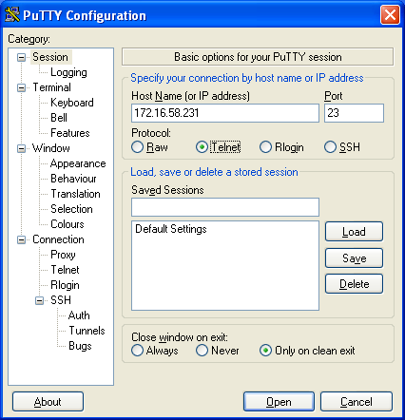

Step 3: It will ask for username and password. Give username and password.

Login into the CDB database

For rename PDB database we need outage of 1 Hour .

show pdbs;
SQL> show pdbs;

CON_ID CON_NAME OPEN MODE RESTRICTED
---------- --------------- ---------- ---------
2 PDB$SEED READ ONLY NO
3 MOFFP READ WRITE NO

login INTO PDB database

Session alter for PDB
SQL> alter session set container=MOFFP ;

Session altered.

Steps for rename the PDB

1.4.1 Shutdown the PDB database
SQL> shu immediate
Pluggable Database closed
1.4.2 Open database in restrict mode
SQL> startup open restrict
Pluggable Database opened

Rename the PDB database name
SQL> alter pluggable database MOFFP rename global_name to MOFFB;

Pluggable database altered.

1.5.1 Check the PDB database name
SQL> show con_name
CON_NAME
---------------
MOFFB

1.5.2

SQL> shu immediate
Pluggable Database closed.

1.5.3

SQL> startup
Pluggable Database opened.

SQL> select * from v$pdbs;

CON_ID DBID CON_UID GUID
---------- ---------- ---------- --------------------------------
NAME OPEN_MODE RES
------------------------------ ---------- ---
OPEN_TIME
---------------------------------------------------------------------------
CREATE_SCN TOTAL_SIZE BLOCK_SIZE RECOVERY SNAPSHOT_PARENT_CON_ID
---------- ---------- ---------- -------- ----------------------
3 3397879673 482220329 52A7758D268700BAE0530AAEA6318EAC
MOFFB READ WRITE NO
21-FEB-18 07.51.47.265 +00:00
9.0365E+12 6.3586E+11 8192 ENABLED 0

\

1.5.4 check the mode of PDB database .

SQL> conn /as sysdba
Connected.
SQL> select name,open_mode from v$pdbs;

NAME OPEN_MODE
------------------------------ ----------
PDB$SEED READ ONLY
MOFFB READ WRITE

